**Instructions on using GitHub**

1. Sign up and creating repository

① Sign up to Github by going to <http://github.com> then fill in your information and click **Sign up for Github**.



② When you are done creating your account, verify through your e-mail then create a new Repository.

③ Name the Repository name as your name then click **Create repository**.

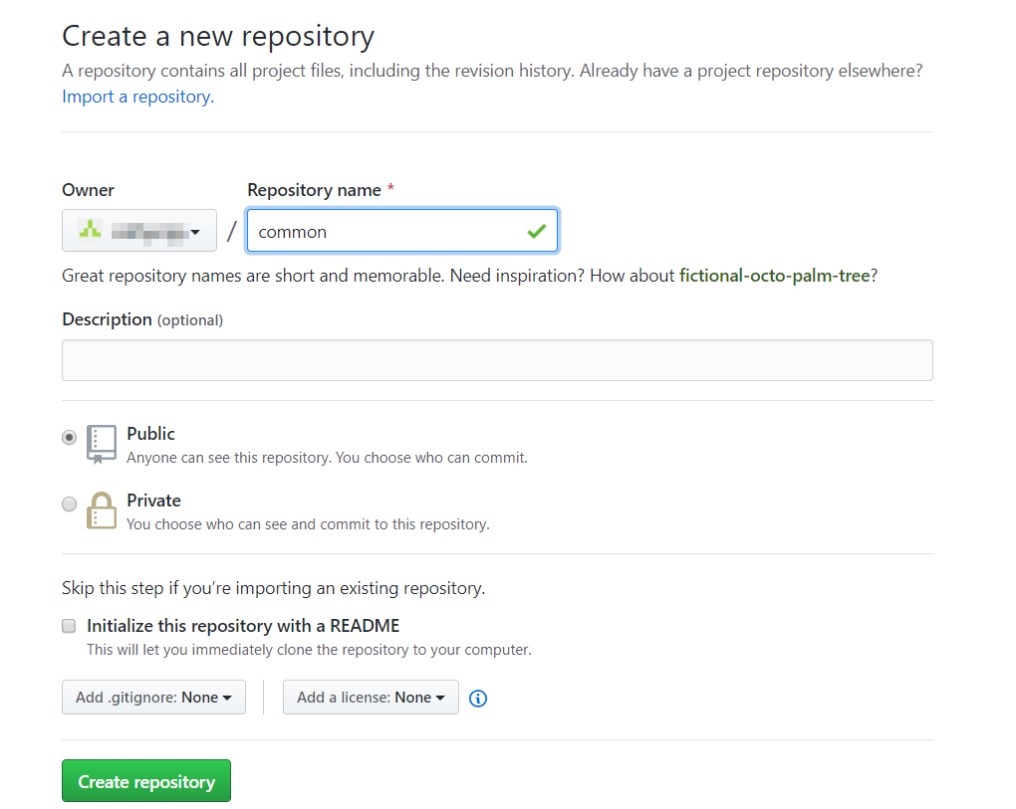

**2. Uploading files**

① To upload a file or create a new file, click the corresponding button displayed below.

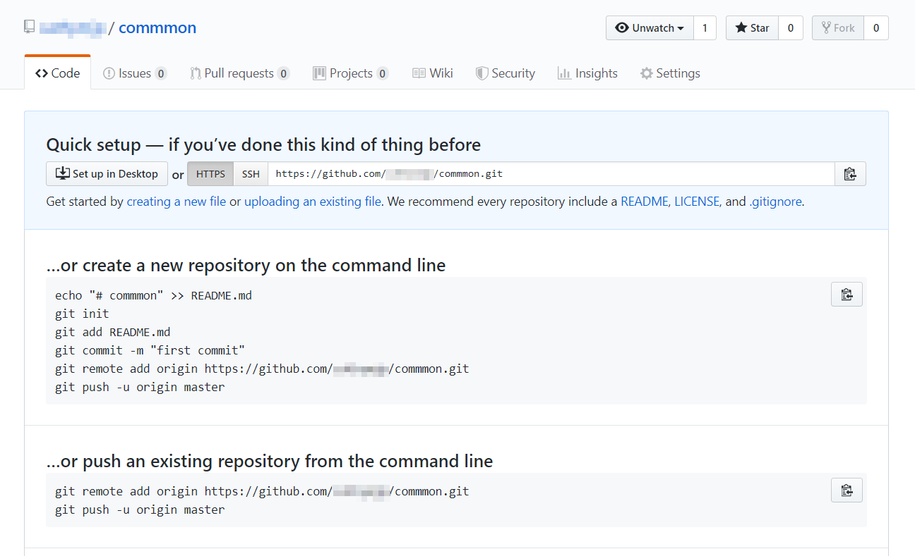

② Either drag files or choose your files from File Explorer.

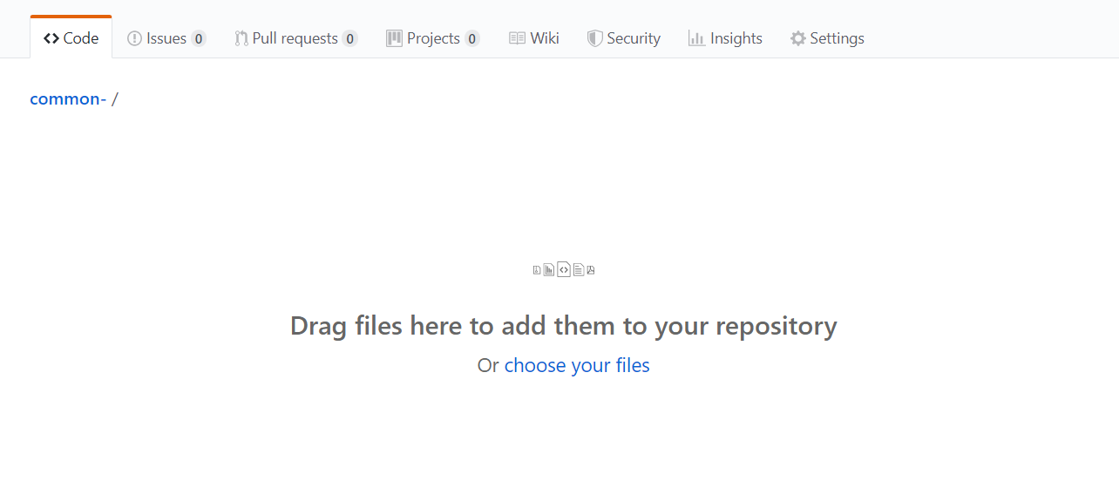

③ Once you are done selecting the file, click **Commit changes**.

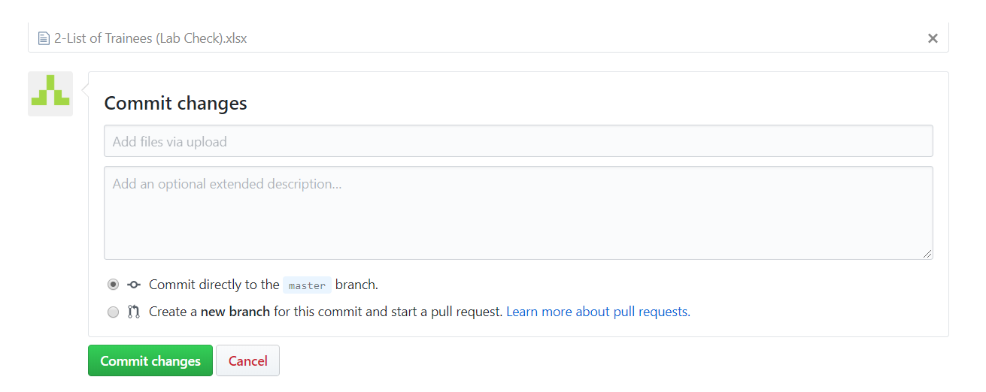

**3. Downloading files**

① To download files, click **Clone or download** button then click **Download ZIP**.

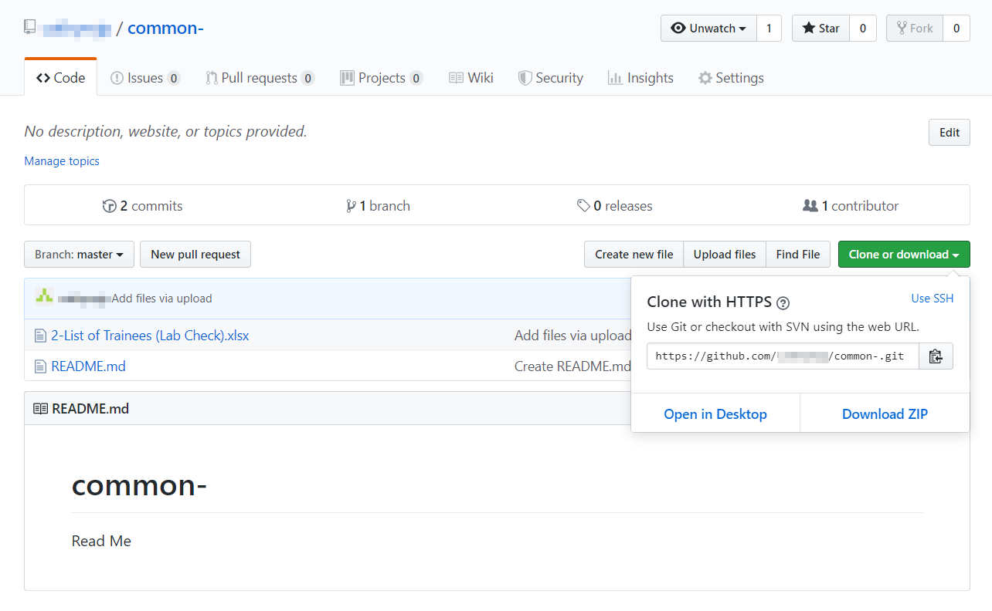

**4. Creating a folder**

① Click **Create new file**.

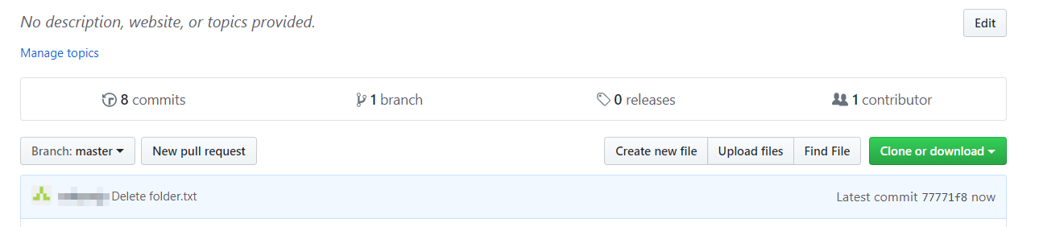

② Enter the name of the folder than add “**/**” sign. For example, if the name of the folder is example, enter **example/**.

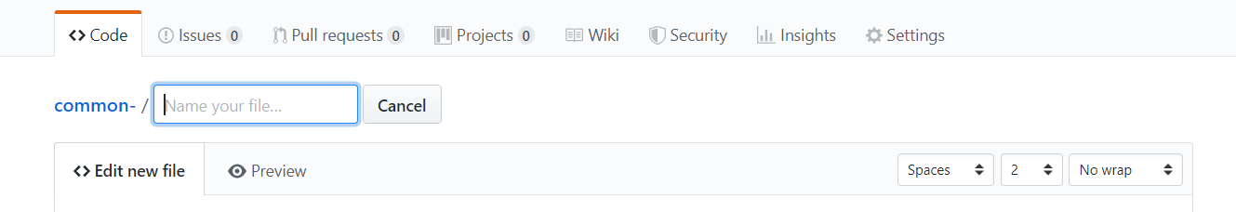

③ Enter README.md in Name your file… field.



④ Click **Commit new file**.

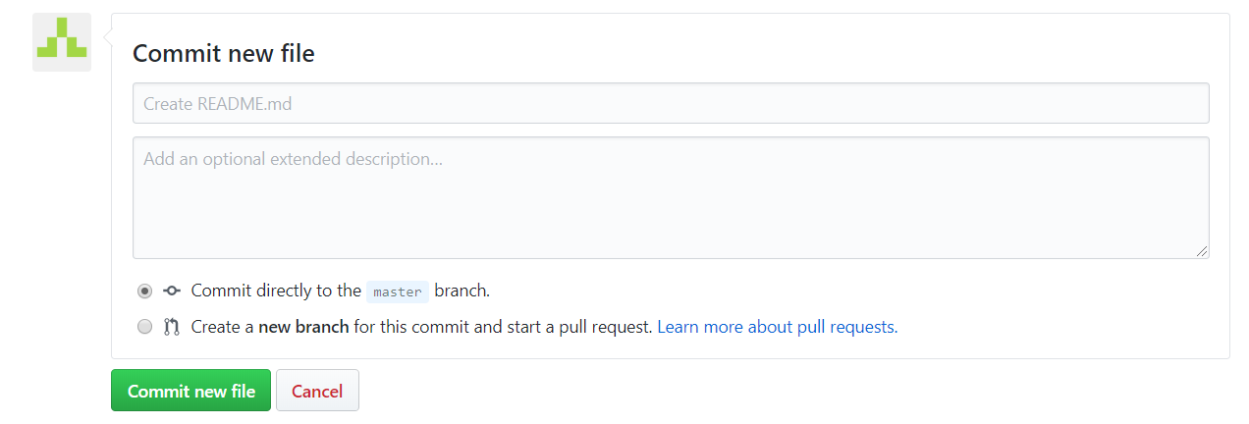

⑤ To upload files, **Click Upload** files.

